8. re arrange the elements(negative come before the positive5Q)21/02/2024

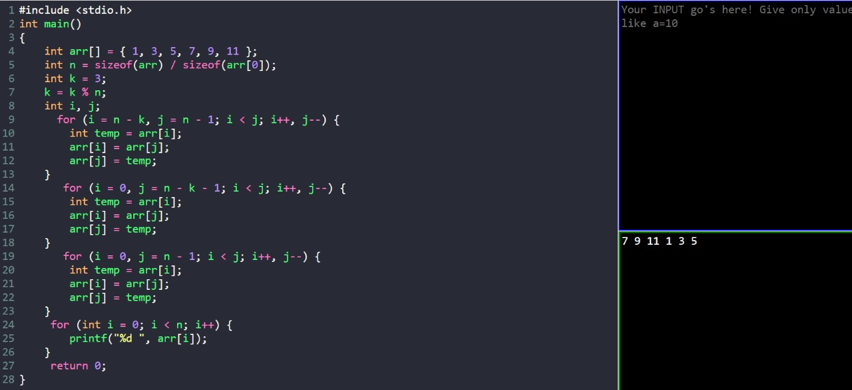

9.longest increasing subarray(3Q) [22/02/2024] from here

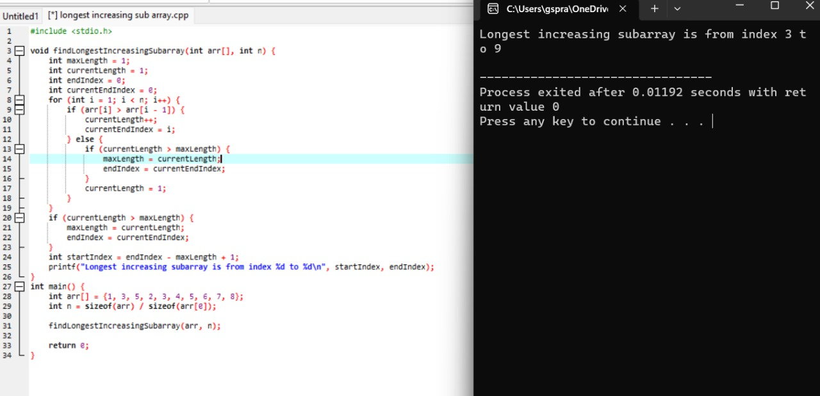

10.longest increasing subarray with equal no of 1s and 0s(10Q)

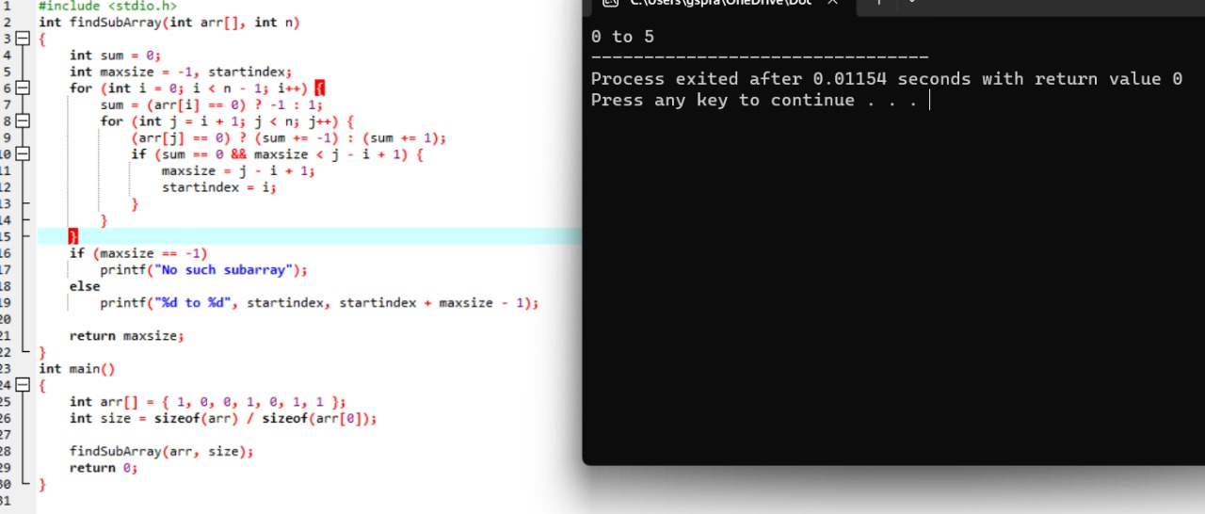

11.smallest missing +ve integer

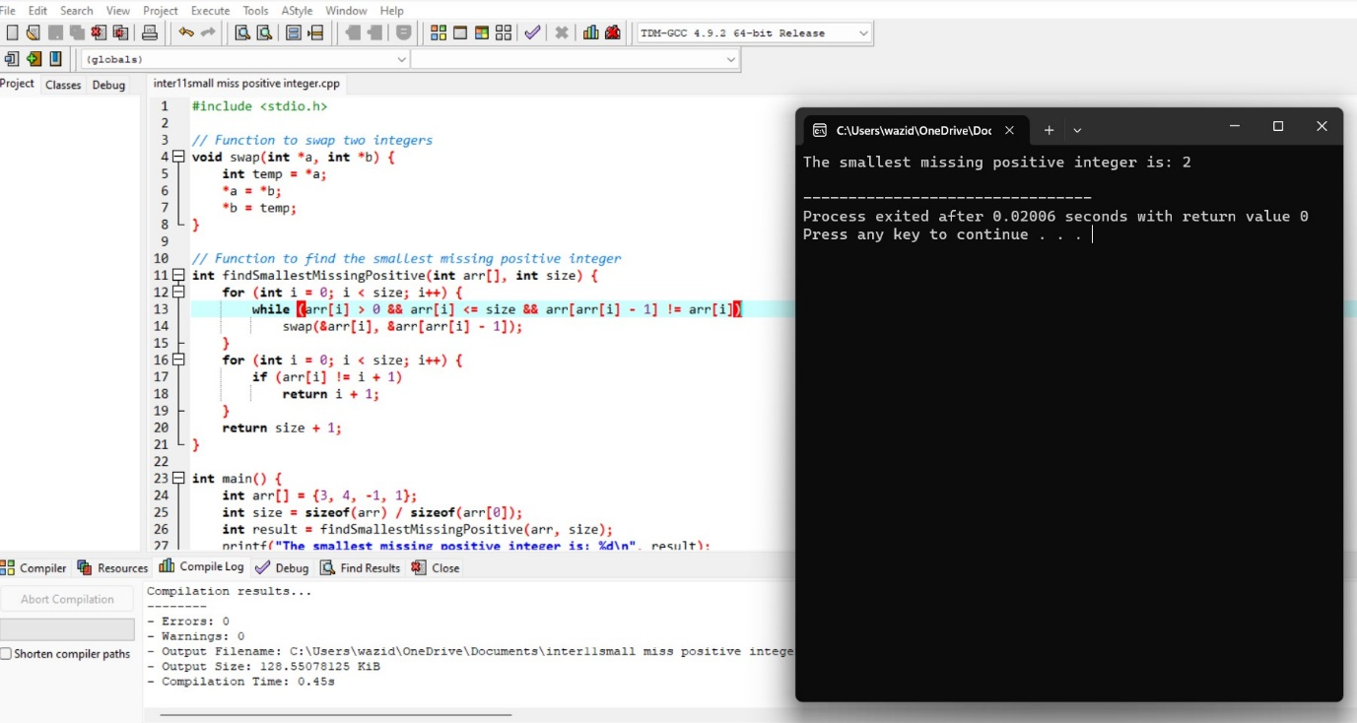

12.two elements has max product

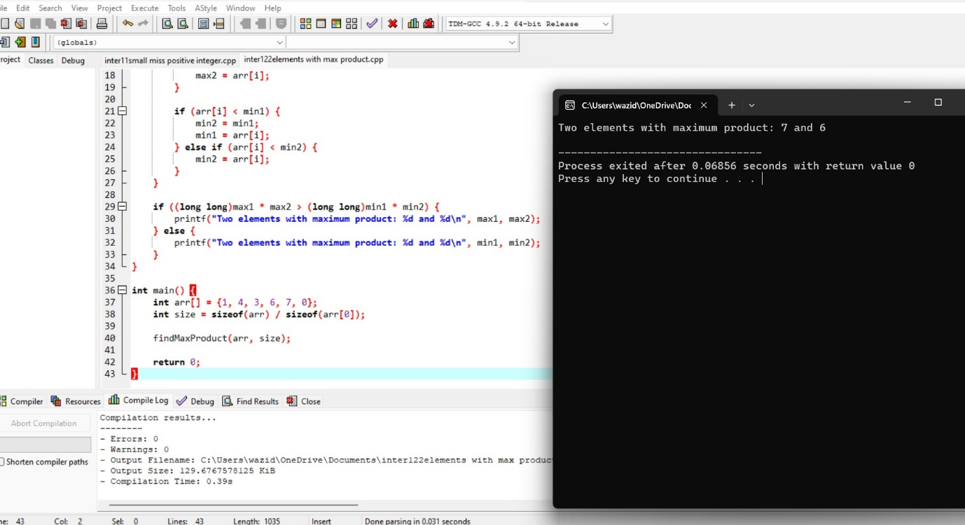

13.subarray with max product

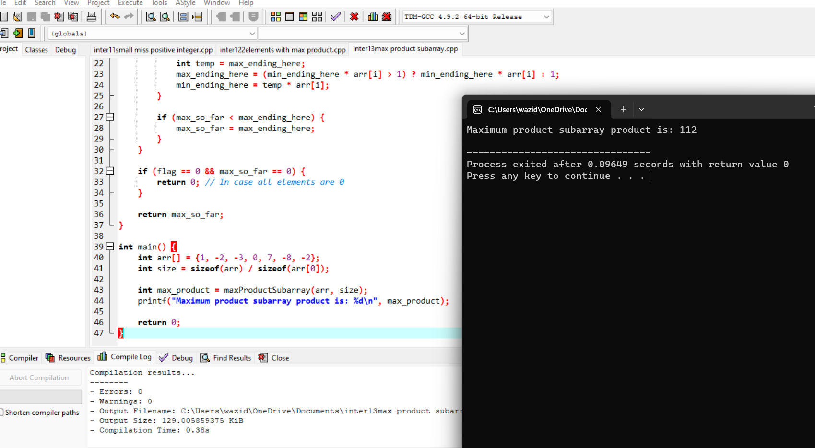

14.longest subarray with sum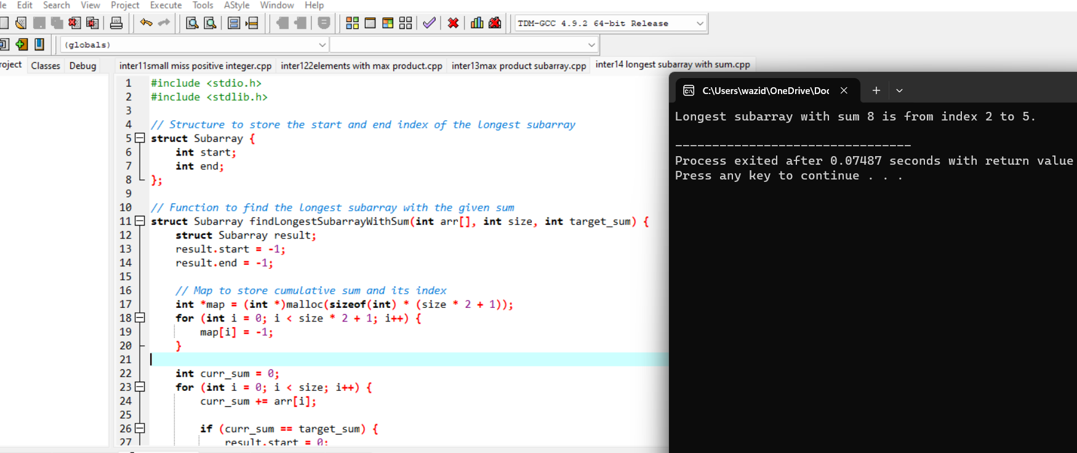

15.find saddle pointin a given matrix

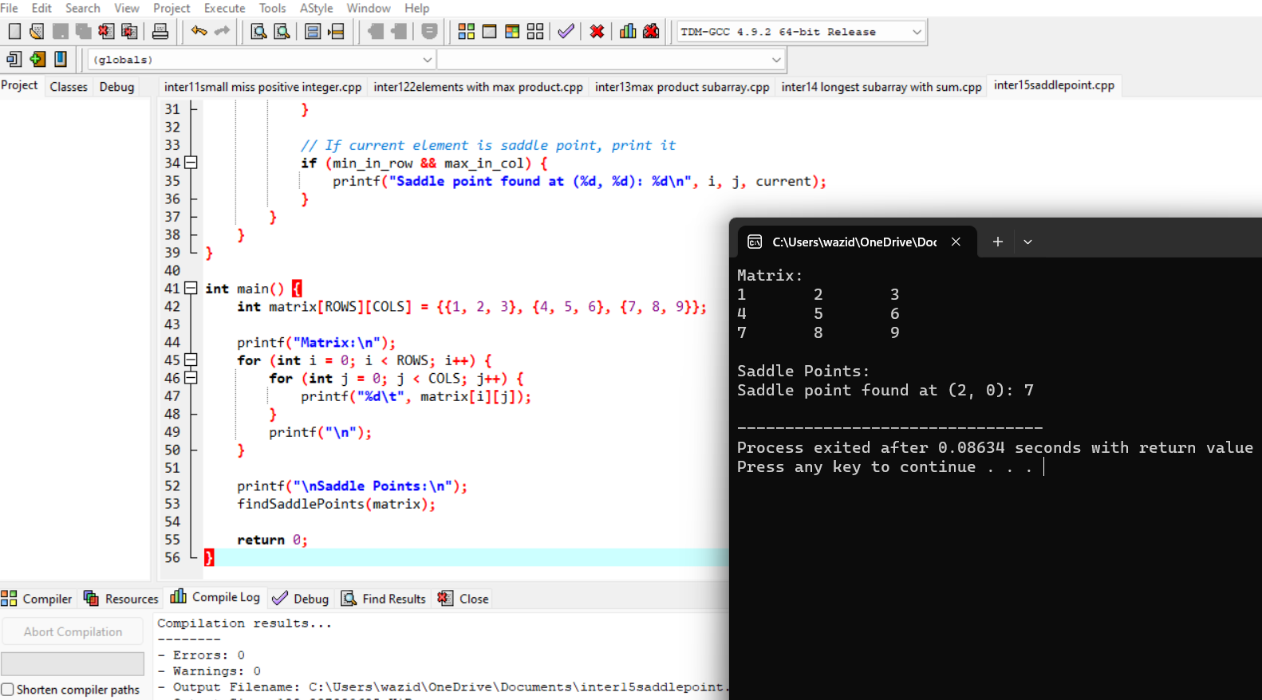

16.swap values of two variables using pointers

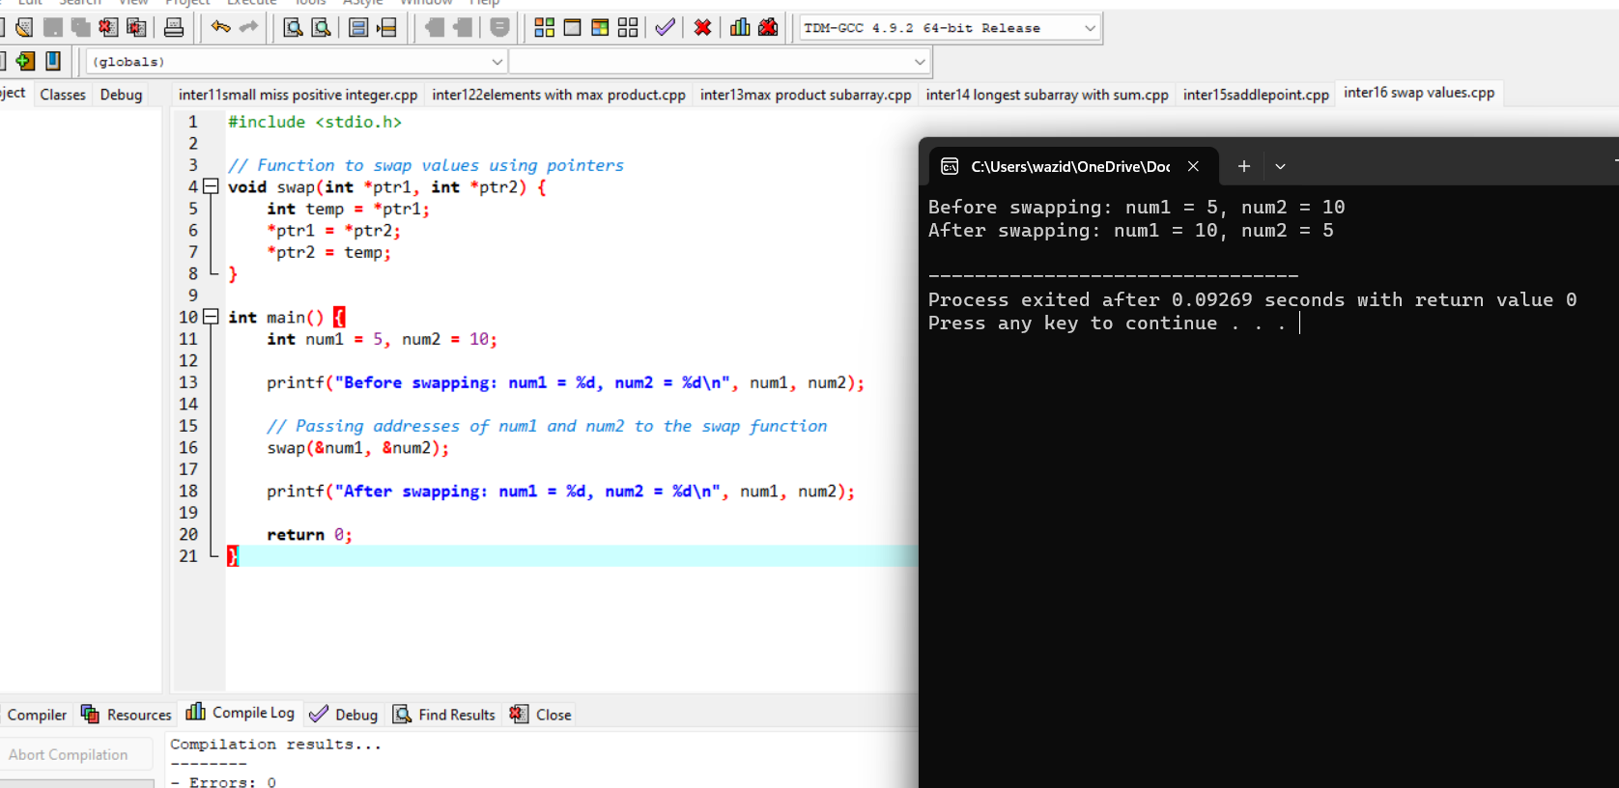

17.length of a string using pointer

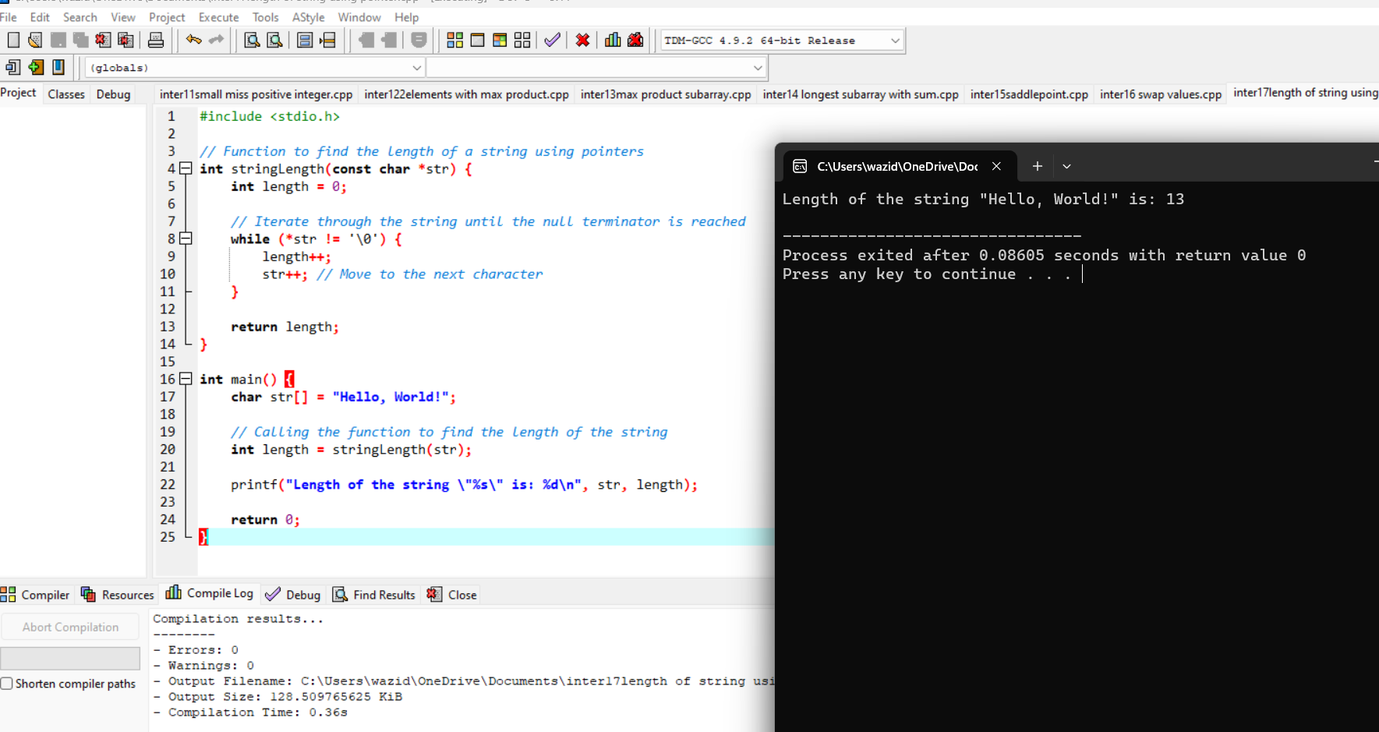

Analytical programs:

1.Longest substring without repeating characters.

#include <stdio.h>

#include <string.h>

#define MAX_CHARS 256

int max(int a, int b) {

return (a > b) ? a : b;

}

void longestUniqueSubsttr(char *str) {

int n = strlen(str);

int visited[MAX_CHARS];

int start = 0;

int currentLength = 1;

int maxLength = 1;

int previousIndex;

for (int i = 0; i < MAX_CHARS; i++)

visited[i] = -1;

visited[str[0]] = 0;

for (int i = 1; i < n; i++) {

previousIndex = visited[str[i]];

if (previousIndex == -1 || i - currentLength > previousIndex)

currentLength++;

else {

if (currentLength > maxLength) {

maxLength = currentLength;

start = i - maxLength;

}

currentLength = i - previousIndex;

}

visited[str[i]] = i;

}

if (currentLength > maxLength) {

maxLength = currentLength;

start = n - maxLength;

}

printf("The longest substring without repeating characters is: ");

for (int i = start; i < start + maxLength; i++)

printf("%c", str[i]);

printf("\n");

}

int main() {

char str[] = "abcabcbb";

longestUniqueSubsttr(str);

return 0;

}

Output:

The length of the longest substring without repeating characters is: 3

2.Maximum product subarray in a given array of integers.

#include <stdio.h>

int max(int a, int b) {

return (a > b) ? a : b;

}

int min(int a, int b) {

return (a < b) ? a : b;

}

int maxProductSubarray(int arr[], int n) {

if (n == 0) {

return 0;

}

int maxEndingHere = arr[0];

int minEndingHere = arr[0];

int maxSoFar = arr[0];

for (int i = 1; i < n; i++) {

int temp = maxEndingHere;

maxEndingHere = max(arr[i], max(arr[i] * maxEndingHere, arr[i] * minEndingHere));

minEndingHere = min(arr[i], min(arr[i] * temp, arr[i] * minEndingHere));

maxSoFar = max(maxSoFar, maxEndingHere);

}

return maxSoFar;

}

int main() {

int arr[] = { 3, 4};

int n = sizeof(arr) / sizeof(arr[0]);

int maxProd = maxProductSubarray(arr, n);

printf("Maximum product subarray is: %d\n", maxProd);

return 0;

}

Output:

Maximum product subarray is: 12

3.Rotates a given array of integers to the right by k steps.

#include <stdio.h>

int main()

{

int arr[] = { 1, 3, 5, 7, 9, 11 };

int n = sizeof(arr) / sizeof(arr[0]);

int k = 3;

k = k % n;

int i, j;

for (i = n - k, j = n - 1; i < j; i++, j--) {

int temp = arr[i];

arr[i] = arr[j];

arr[j] = temp;

}

for (i = 0, j = n - k - 1; i < j; i++, j--) {

int temp = arr[i];

arr[i] = arr[j];

arr[j] = temp;

}

for (i = 0, j = n - 1; i < j; i++, j--) {

int temp = arr[i];

arr[i] = arr[j];

arr[j] = temp;

}

for (int i = 0; i < n; i++) {

printf("%d ", arr[i]);

}

return 0;

}

Output:

7 9 11 1 3 5

--------------------------------

Process exited after 0.09181 seconds with return value 0

Press any key to continue . . .

4.Longest common prefix string amongst an array of strings.

#include <stdio.h>

#include <stdlib.h>

#include <string.h>

int min(int a, int b) {

return (a < b) ? a : b;

}

char* longestCommonPrefix(char** strs, int strsSize) {

if (strsSize == 0)

return "";

int minLen = strlen(strs[0]);

for (int i = 1; i < strsSize; ++i)

minLen = min(minLen, strlen(strs[i]));

int i, j;

for (i = 0; i < minLen; ++i) {

for (j = 1; j < strsSize; ++j) {

if (strs[j][i] != strs[j - 1][i])

break;

}

if (j != strsSize)

break;

}

char* commonPrefix = (char*)malloc(sizeof(char) * (i + 1));

strncpy(commonPrefix, strs[0], i);

commonPrefix[i] = '\0';

return commonPrefix;

}

int main() {

char *strings[] = {"flower", "flow", "flight"};

int size = sizeof(strings) / sizeof(strings[0]);

char *prefix = longestCommonPrefix(strings, size);

printf("Longest common prefix: %s\n", prefix);

free(prefix);

return 0;

}

Output:

Longest common prefix:fl

5.combinations of a given length k.

#include <stdio.h>

void printCombination(int arr[], int n, int r, int index, int data[], int i) {

if (index == r) {

for (int j = 0; j < r; j++)

printf("%d ", data[j]);

printf("\n");

return;

}

if (i >= n)

return;

data[index] = arr[i];

printCombination(arr, n, r, index + 1, data, i + 1);

while (i < n - 1 && arr[i] == arr[i + 1])

i++;

printCombination(arr, n, r, index, data, i + 1);

}

void combinations(int arr[], int n, int r) {

int data[r];

printCombination(arr, n, r, 0, data, 0);

}

int main() {

int arr[] = {1, 2, 3, 4};

int n = sizeof(arr) / sizeof(arr[0]);

int k = 2;

printf("Distinct combinations of length %d:\n", k);

combinations(arr, n, k);

return 0;

}

Output: Distinct combinations of length 2:

1 2

1 3

1 4

2 3

2 4

3 4

6. removes all duplicates from a sorted array.

#include <stdio.h>

int removeDuplicates(int arr[], int n) {

if (n == 0 || n == 1)

return n;

int j = 0;

for (int i = 0; i < n - 1; i++) {

if (arr[i] != arr[i + 1]) {

arr[j++] = arr[i];

}

}

arr[j++] = arr[n - 1];

return j;

}

int main() {

int arr[] = {1, 2, 2, 3, 4, 4, 4, 5};

int n = sizeof(arr) / sizeof(arr[0]);

printf("Original array: ");

for (int i = 0; i < n; i++)

printf("%d ", arr[i]);

printf("\n");

n = removeDuplicates(arr, n);

printf("Array after removing duplicates: ");

for (int i = 0; i < n; i++)

printf("%d ", arr[i]);

printf("\n");

return 0;

}

Output:

Original array: 1 2 2 3 4 4 4 5

Array after removing duplicates: 1 2 3 4 5

7. Implement a function that determines if a given Sudoku board is valid.

#include <stdio.h>

#include <stdbool.h>

#define SIZE 9

bool isValidRow(char board[SIZE][SIZE], int row) {

bool visited[SIZE + 1] = {false};

for (int col = 0; col < SIZE; col++) {

if (board[row][col] != '.') {

int num = board[row][col] - '0';

if (visited[num])

return false;

visited[num] = true;

}

}

return true;

}

bool isValidCol(char board[SIZE][SIZE], int col) {

bool visited[SIZE + 1] = {false};

for (int row = 0; row < SIZE; row++) {

if (board[row][col] != '.') {

int num = board[row][col] - '0';

if (visited[num])

return false;

visited[num] = true;

}

}

return true;

}

bool isValidSubgrid(char board[SIZE][SIZE], int startRow, int startCol) {

bool visited[SIZE + 1] = {false};

for (int row = startRow; row < startRow + 3; row++) {

for (int col = startCol; col < startCol + 3; col++) {

if (board[row][col] != '.') {

int num = board[row][col] - '0';

if (visited[num])

return false;

visited[num] = true;

}

}

}

return true;

}

bool isValidSudoku(char board[SIZE][SIZE]) {

for (int i = 0; i < SIZE; i++) {

if (!isValidRow(board, i))

return false;

}

for (int i = 0; i < SIZE; i++) {

if (!isValidCol(board, i))

return false;

}

for (int startRow = 0; startRow < SIZE; startRow += 3) {

for (int startCol = 0; startCol < SIZE; startCol += 3) {

if (!isValidSubgrid(board, startRow, startCol))

return false;

}

}

return true;

}

int main() {

char board[SIZE][SIZE] = {

{'5', '3', '.', '.', '7', '.', '.', '.', '.'},

{'6', '.', '.', '1', '9', '5', '.', '.', '.'},

{'.', '9', '8', '.', '.', '.', '.', '6', '.'},

{'8', '.', '.', '.', '6', '.', '.', '.', '3'},

{'4', '.', '.', '8', '.', '3', '.', '.', '1'},

{'7', '.', '.', '.', '2', '.', '.', '.', '6'},

{'.', '6', '.', '.', '.', '.', '2', '8', '.'},

{'.', '.', '.', '4', '1', '9', '.', '.', '5'},

{'.', '.', '.', '.', '8', '.', '.', '7', '9'}

};

if (isValidSudoku(board))

printf("The Sudoku board is valid.\n");

else

printf("The Sudoku board is not valid.\n");

return 0;

}

Output: The Sudoku board is valid.

8.Implement a function that returns the index of the first occurrence of a target value in a sorted array

#include <stdio.h>

int findFirstOccurrence(int arr[], int size, int target) {

int low = 0;

int high = size - 1;

int result = -1;

while (low <= high) {

int mid = low + (high - low) / 2;

if (arr[mid] == target) {

result = mid;

high = mid - 1;

} else if (arr[mid] < target) {

low = mid + 1;

} else {

high = mid - 1;

}

}

return result;

}

int main() {

int arr[] = {1, 2, 3, 4, 4, 4, 5, 6};

int size = sizeof(arr) / sizeof(arr[0]);

int target = 3;

int index = findFirstOccurrence(arr, size, target);

if (index != -1) {

printf("First occurrence of %d is at index %d\n", target, index);

} else {

printf("%d not found in the array\n", target);

}

return 0;

}

Output:

First occurrence of 3 is at index 2